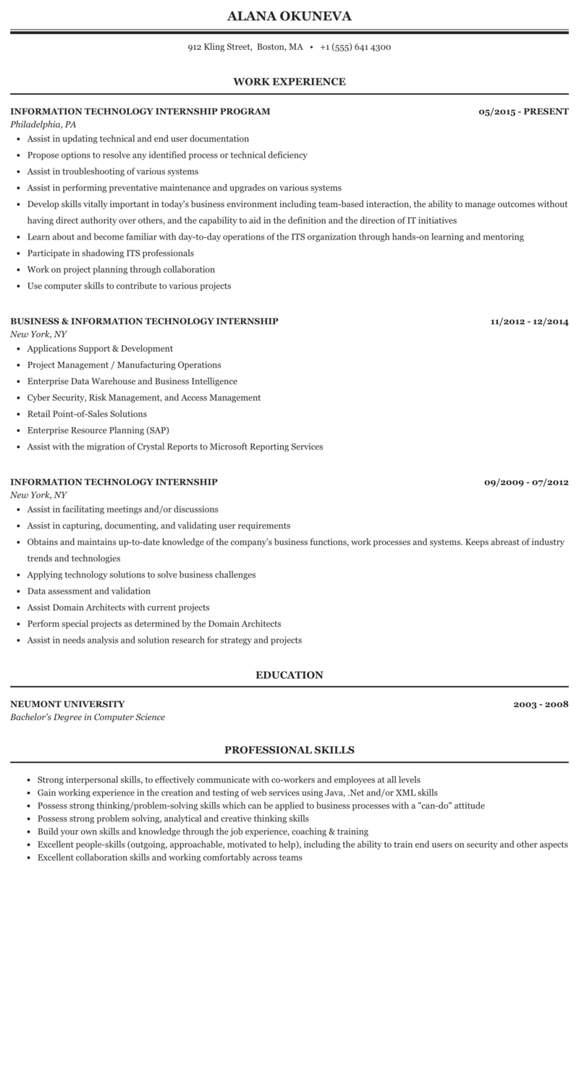
ALANA OKUNEVA
912 Kling Street, Boston, MA.
+1 (555) 641 4300
WORK EXPERIENCE
INFORMATION TECHNOLOGY INTERNSHIP PROGRAM
Philadelphia, PA
• Assist in updating technical and end user documentation
• Propose options to resolve any identified process or technical deficiency
• Assist in troubleshooting of various systems
• Assist in performing preventative maintenance and upgrades on various systems
05/2015-PRESENT
• Develop skills vitally important in today's business environment including team-based interaction, the ability to manage outcomes without having direct authority over others, and the capability to aid in the definition and the direction of IT initiatives
• Learn about and become familiar with day-to-day operations of the ITS organization through hands-on learning and mentoring
• Participate in shadowing ITS professionals
• Work on project planning through collaboration
• Use computer skills to contribute to various projects
BUSINESS & INFORMATION TECHNOLOGY INTERNSHIP New York, NY
• Applications Support & Development
• Project Management / Manufacturing Operations
• Enterprise Data Warehouse and Business Intelligence
⚫ Cyber Security, Risk Management, and Access Management
• Retail Point-of-Sales Solutions
• Enterprise Resource Planning (SAP)
• Assist with the migration of Crystal Reports to Microsoft Reporting Services
11/2012 - 12/2014
INFORMATION TECHNOLOGY INTERNSHIP
New York, NY
• Assist in facilitating meetings and/or discussions
• Assist in capturing, documenting, and validating user requirements
09/2009-07/2012
• Obtains and maintains up-to-date knowledge of the company's business functions, work processes and systems. Keeps abreast of industry trends and technologies
• Applying technology solutions to solve business challenges
⚫ Data assessment and validation
• Assist Domain Architects with current projects
• Perform special projects as determined by the Domain Architects
• Assist in needs analysis and solution research for strategy and projects
NEUMONT UNIVERSITY
Bachelor's Degree in Computer Science
EDUCATION
PROFESSIONAL SKILLS
2003-2008
• Strong interpersonal skills, to effectively communicate with co-workers and employees at all levels
• Gain working experience in the creation and testing of web services using Java, .Net and/or XML skills
⚫ Possess strong thinking/problem-solving skills which can be applied to business processes with a "can-do" attitude
• Possess strong problem solving, analytical and creative thinking skills
• Build your own skills and knowledge through the job experience, coaching & training
• Excellent people-skills (outgoing, approachable, motivated to help), including the ability to train end users on security and other aspects • Excellent collaboration skills and working comfortably across teams

